**21MCA1117 – Ayush Kumar**

**Lab Exercise - Date : 08-03-2022**

**Topic: IF condition**

1) BMI is a measure of body fat based on height and weight that applies to adult men and women. BMI can be used to indicate if you are overweight, obese, underweight or normal. Write a Java Application to calculate BMI based on a person's weight and height. The math formula for calculating BMI is shown below:

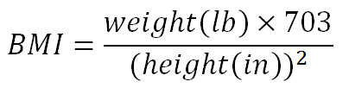

Simple BMI categories include

• Underweight when BMI is less than 18.5

• Normal weight when BMI is between 18.5 and 25

import java.util.*;

class BodyMassIndex{

public static void main(String args[]){

float weight,height,BMI;

Scanner myObj = new Scanner(System.in);

System.out.println("Weight = ");

weight = myObj.nextFloat();

System.out.println("Height = ");

height = myObj.nextFloat();

BMI = (weight*703)/(height*height);

if(BMI<18.5)

{

System.out.println("Underweight");

}

else if(BMI>=18.5 && BMI<25)

{

System.out.println("Normal Weight");

}

else

{

System.out.println("Overweight");

}

}

}

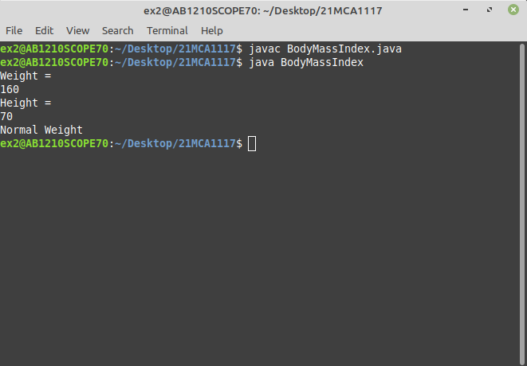

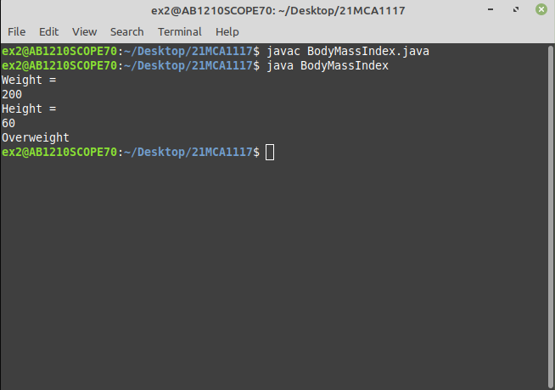

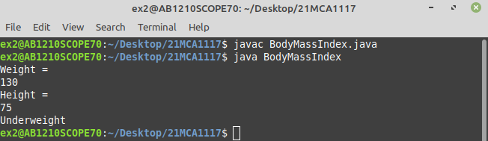

2) An Insurance company implements following rules to calculate premium:

- The person’s health is excellent and the person age is between 25 and 35 years and lives in a city and is a male then the premium is Rs.4 per thousand and his policy amount cannot exceed Rs. 2 lakhs.

- The person satisfies all the above conditions except that the sex is female then the premium is Rs.3 per thousand and the policy amount cannot exceed Rs.1 lakh.

- The person’s health is poor and the person age is between 25 and 35 years and lives in a village and is is a male then the premium is Rs. 6 per thousand and the policy amount cannot exceed Rs.10,000.

Develop java application to display the output whether the person should be insured or not , the premium rate and maximum amount for which the person can be insured.

import java.util.*;

class Insurance{

public static void main(String[] args){

int age;

Scanner myObj = new Scanner(System.in);

System.out.println("Enter the person's age - ");

age = myObj.nextInt();

System.out.println("Enter the person's sex - ");

String sex = myObj.neimportxt();

System.out.println("Enter the person's health - ");

String health = myObj.next();

if(age>=25 && age<35)

{

if(sex.equals("male"))

{

if(health.equals("excellent"))

{import

System.out.println("Person can be insured with a maximum amount of 2 lakhs");

int amount = myObj.nextInt();

int premium = (amount / 1000)*4;

System.out.println("Premium amount = Rs 4 per 1000/ is = " + premium);

}

if(health.equals("poor"))

{

System.out.println("Person can be insured with a maximum amount of 10,000");

int amount = myObj.nextInt();

int premium = (amount / 1000)*6;

System.out.println("Premium amount = Rs 6 per 1000/-" + premium);

}

}

if(sex.equals("female"))

{

System.out.println("Person can be insured with a maximum amount of 1 lakhs");

int amount = myObj.nextInt();

int premium = (amount / 1000)*3;

System.out.println("Premium amount = Rs 3 per 1000/-" + premium);

}

}

else

{

System.out.println("Person can't be insured");

}

}

}



